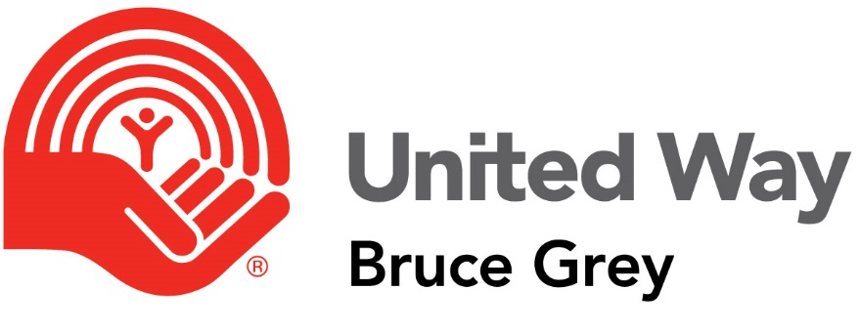

Grant Application
  - Single Year Funding - Part A

2019

Deadline: Friday Dec. 21, 2018

Download this document and the Program Information document to your computer.

Please Note
This document should be completed only once.
The Program Information section should be completed for each program or group of activities for which your agency is requesting funding. You can add multiple copies of this section within this document.

Application Checklist
- Cover letter addressing agency application
- Member Agency Agreement (Part A)
- Program Information Document (Part B) – for EACH Program / set of activities for which your agency is requesting United Way funding
- Most recent audited financial statements
- Most recent annual report
- Current fiscal budget
- Most recent strategic/organizational plan (if one exists). If one does not exist, explain why in your cover letter.
- Program/project plan for the funds you are requesting (if applicable)

Please submit the following:
- 1 signed original complete application (all documents)
- 2 additional photocopies of the complete application
- 1 electronic copy of the complete application & documents to execdir@unitedwaybg.com

Agency Information
Name of Agency :
Mailing Address :
Telephone Number :
Fax Number :
Name of Contact Person :
Title :
Telephone number :
Email Address :
Name of Executive Director:
Telephone Number :
Email Address :
Name of Board Chair :
Telephone Number :
Email Address :
Date of Last Annual General Meeting :
Date of most recent audited financial statement :
Canada Revenue Agency Charitable No.:

This Charitable Registration Number is for a:
- Local Organization (locally incorporated)
- Provincial Organization (provincial board & governance)
- National Organization (national board & governance)

Agency Questionnaire
Complete this questionnaire, reviewing each question and selecting the appropriate response. Answering No, or N/A (Not applicable) to a question does not suggest that an agency is doing anything wrong, it forms the basis for determining agency needs.
We realize Yes/No questions can have answers that are more nuanced than a simple Yes/No. Please add additional context in the comments section at the end if you feel the need to qualify any responses with additional information.
Please answer yes, no, or N/A to the following statements. Provide context in comments section as necessary.

Please share your agency’s Mission Statement:

Please share your agency’s vision Statement:

Registered Charitable Status | Yes | No | N/A
Our agency is legally constituted and incorporated as a charitable organization.
Our agency has had its charitable status revoked by the CRA in the past.
Comments:

policy and procedure |  | Yes | No | N/A
Our agency has and adheres to privacy policies that meet the requirements of the relevant federal and provincial privacy legislation.
Date of last review/approval by board:_____________ (DD/Mon/YYYY)
Our organization has and adheres to human resources policies and procedures.
Date of last review/approval by board:_____________ (DD/Mon/YYYY)
Our organization has and adheres to diversity/inclusivity/accessibility/equity statements.
Date of last review/approval by board:_____________ (DD/Mon/YYYY)
Our organization has and adheres to anti-discrimination/anti-harassment policies/procedures.
Date of last review/approval by board:_____________ (DD/Mon/YYYY)
Our organization has and adheres to volunteer policies and procedures.
Date of last review/approval by board:_____________ (DD/Mon/YYYY)
 | Comments:

 | Governance | Yes | No | N/A
Our agency has an active, responsible, voluntary board which meets regularly and ensures effective governance over the organization.
Date of last review/approval by board:_____________ (DD/Mon/YYYY)
We work with vulnerable clients and have a prevention of abuse policy and related insurance coverage.
Date of last review/approval by board:_____________ (DD/Mon/YYYY)
Our board sets limitations on terms of office for board members and ensures those limitations are honoured.
Date of last review/approval by board:_____________ (DD/Mon/YYYY)
Comments:

Mission, Vision and Planning | Yes | No | N/A
Our board establishes and periodically reviews the organizational mission, vision and/or values statements.
Our agency has established a strategic plan to achieve its mission in the community and engages our stakeholders, staff and board in the process.
Our agency regularly reviews its strategic plan to determine progress in achieving key goals and objectives.
Comments:

Support of United Way |  | Yes |  | No | N/A
Our agency prominently displays the United Way of Bruce Grey member agency sign at all of its locations.
Our agency uses the United Way member agency logo on all of its promotional and printed materials, including our annual report.
Funds received from the United Way are clearly noted in our audited financial statements.
Our agency conducts an internal United Way Workplace Campaign with participation from staff and volunteers.
By showcasing your participation and support at United Way special events, you make a difference in donations to the United Way.
How many United Way events did your agency participate in last year? Please list.

 | Event  ________________________________________  ________________________________________  ________________________________________  ________________________________________  ________________________________________  ________________________________________ |  | Board |  |  | Staff

Board of Directors
Full Name |  | Position on Board |  | # of Years on Board

Agency Staff
Full Name |  | Position | Full-time | Part-time | Contract | Volunteer
 |  | Total Counts:

Summary of Program Funding Request

This submission was approved in accordance with our organizations on our meeting held on: __________________________________ (date).
Please check the following:
- We have reviewed the Guidebook and discussed the application with United Way staff
- We certify, to the best of our knowledge, the information provided in this application is accurate, complete, and endorsed by the agency we represent.
- We acknowledge that if this application is approved, ___________________ (Name of Agency) agrees to comply with the UWBG Member Agency Agreement for funding.
- We acknowledge that we must adhere to UWBG funding campaign roles and responsibilities, including actively participating in campaign, special events, placement of UWBG logo on appropriate materials, and participate in Member Agency meetings.
UWBG representatives are authorized to discuss this funding application with other funders and partners named herein.
Sincerely,

President/Chair or Treasurer (circle)
_____________________________
^{Print Name}
__________________
^{Date (DD/Mon/YYYY)}

Executive Director
_____________________________
_{Print Name}
__________________
^{Date (DD/Mon/YYYY)}

We, the undersigned, have provided Board members the opportunity to review this submission and they are aware of this application.

_____________________________  ^{Board Chair Signature}  ___________________  ^{Date (DD/Mon/YYYY)} | _____________________________  Executive Director/Senior Administrator Signature  ___________________  ^{Date (DD/Mon/YYYY)}

