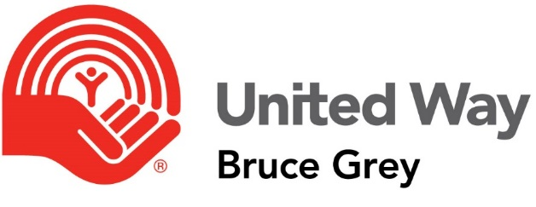

Program Information
  - Part B
Copy and complete this document for each project/activity for which your agency is requesting funding.

Name of Agency: ___________________________________

Name of Project / Activities: ___________________________________

Amount requested for this program / these activities for 2018:
$ ____________

Is this a new program for your agency?
Yes No
If no, how many years has your agency operated the program? _________ years
How many years has United Way funded this program? _________ years
What amount did you receive from UW in 2017, if any: $ _____________
Is this year’s request more than last year’s grant? Yes No

Under which of the United Way’s priority areas does this program or do these activities fall?

- From Poverty to Possibility
- Healthy People, Strong Community
- All That Kids Can Be

Which municipalities in Bruce & Grey Counties will This project / These activities serve? (check all that apply)

Bruce
- Arran-Elderslie
- Brockton
- Huron-Kinloss
- Kincardine
- Northern Bruce Peninsula
- Saugeen Shores
- South Bruce Peninsula
- South Bruce
- Neyaashiinigmiing
- Saugeen First Nation
Grey
- Chatsworth
- Georgian Bluffs
- Meaford
- Owen Sound
- Southgate
- West Grey
- The Blue Mountains

What local need is being addressed by this program?

Briefly describe any local research or background rationale that supports this need in Bruce & Grey counties.
Provide references where applicable.

Briefly explain how clients and other stakeholders are involved in program development, delivery and evaluation.

Has this program identified any significant new emerging needs or trends?
Yes No
If yes, briefly explain how you have addressed or will address these.

Does this program work in partnership with any other organization(s)?
Yes No
If yes, please explain their role, and how the partnership helps service delivery.

Please complete the following program plan chart or attach your own to this application.
Project Goal(s):
Target Groups | Activities | Project Outputs | Expected Outcomes

Goals: List one or two main goals that this project has. If someone were to ask you ‘the point’ of the project, this is what you’d tell them. It’s the overarching result you wish to achieve.
Target Groups: Who specifically are you seeking to support with this project, and how many people do you expect to reach – include the geographic areas that will be directly served by this project/these activities.
Activities & Outputs: What specific activities will you be performing to achieve your goals? Activities usually relate directly to Project Outputs in that outputs are a way to measure your activities. For example, an activity might be ‘holding weekly information sessions about navigating social services,’ and the associated outputs would be things like ‘# of people attending weekly/monthly/total’, ‘# of sessions held’.
Outcomes should be SMART: Specific, Measurable, Achievable, Realistic, and Time-specific. Outcomes are relatable to goals in that they are essentially the components of the goal. The outcomes, taken together, indicate that the goal has or has not been achieved. A goal may not be directly measurable, but outcomes should always be measurable, and collectively act as proxies for the goal.
Most importantly: Activities should related directly to outputs and expected outcomes. You should not have an expected outcome that has no related activities or outputs.

How many Full Time Equivalent employees (FTEs) are/will be used to deliver this program?

____________

Does/will the agency use volunteers in the delivery of this program? Yes No
Yes No
If yes, how many during the past fiscal year? ______________
If no, briefly explain the barriers that prevent this?

Please identify other key resources (inputs) necessary to run this program:

Why does this program need United Way funding?

What other sources of funding have you secured or requested specifically for this program?

If the agency has requested increased funding for this program, please explain how these additional funds will be used? (i.e.) additional staff, programming, equipment, reduce waitlists, etc.

Please identify any additional outcomes/benefits to clients that will directly result from this increased funding.

Has the number of clients served increased from the previous year reported?
Yes No
If yes, please explain the increase or decrease and any factors that you believe may have contributed to this.

Please complete the accompanying Budget Workbook, which outlines your program funding that has been requested.

The worksheet is divided into two categories – Revenue and Expenditures. The right handed side (Program A, B, C, D) is for specific programs that we are fund directly.

There is an ‘other’ field which is located at the bottom of the sheet where you can add any missing categories that we should know about.

If there is a category that doesn’t apply to your agency please indicate it as not applicable.

